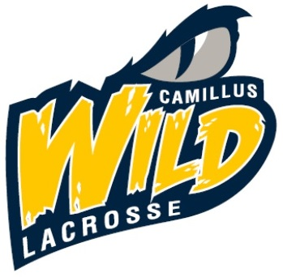  Camillus youth lacrosse association  2020 registration  Registration & General Information at www.camillusyouthlax.org  CYLA is open to all boys and girls in grades K-6 (current school year) within the West Genesee School District including Holy Family. Components of CYLA include:  Grade K – twice weekly introductory/fun “practices” occurring in May & June. Cost: $40.00 per player.  Grades 1 & 2 – twice weekly practices and scrimmages occurring in May & June. Cost: $70.00 per player.  Grades 3/4 & 5/6 – Clinic-based practices/scrimmages will begin in late April, followed by teams playing in the 2020 Upstate Lacrosse Association (ULA) with 1 local game & practice per week beginning in mid-June and ending in late July. Cost: $95.00 per player.  CYLA is pleased to offer opportunities for girls and boys in grades K-6 during the spring and summer months at the same low cost as last year! Our organization began in 2012 with the mission to grow the participation and enjoyment of lacrosse for school age children in the West Genesee District, including Holy Family. We enrolled 300 girls and boys in the 2019 season and look forward to many more years of growing the sport of lacrosse in our community!  For Wild gear check out: http://stores.graph-tex.com/cwild_lax20 | Register your child online at www.camillusyouthlax.org  ────  Registration for Grades K, 1 & 2 from March 1st - April 15th  ────  Registration for Grades 3-6 from March 1st – March 31st Late Registration from April 1st – April 15th with an additional $35.00 late fee  ────  Walk – up registration will be held at Shove Park March 20, 2020 from 5 p.m. – 7 p.m.  Questions? Email cylareg@gmail.com

